# Installation Instructions

## Install Sitecore SXA 1.8

1. Please use the following instructions <https://tothecore.sk/2018/11/29/sitecore-sxa-1-8-installation-guide-for-development-machine/>

|  |
| --- |
| Note:  Don´t forget to create a Tenant with the following parameters:  **Tenant name:** Hackathon  **Web site name: SXA** Website  <https://www.youtube.com/watch?v=8G7UcNyTHBo> |

## Install Image filter component

1. Download the following zip file hackathon.image.filter.zip from <https://github.com/Sitecore-Hackathon/2019-Wolfenstein/tree/master/sc.package>
2. Upload the zip file using Development Tools, Installation Wizard

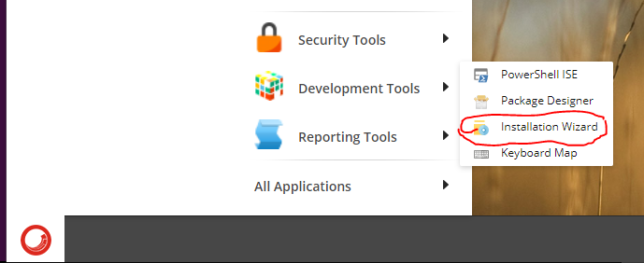

## Preview page test

* Using Content Editor, go to **/sitecore/content/Hackathon/SXA Website/Data/Media**
* Click on PRESENTATION
* Click on Preview

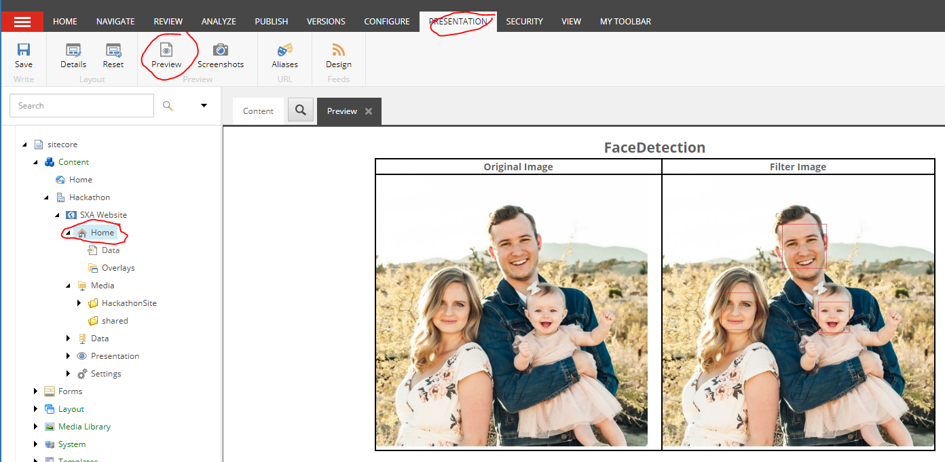

* Use right scroll to see all images samples

## Project Structure

* Templates files are on **/sitecore/templates/Feature/Media**

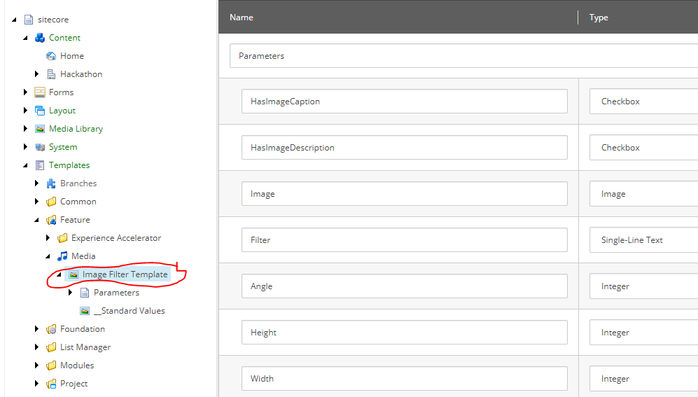

* Images to use in filters are on **/sitecore/media library/Project/Hackathon/SXA Website**

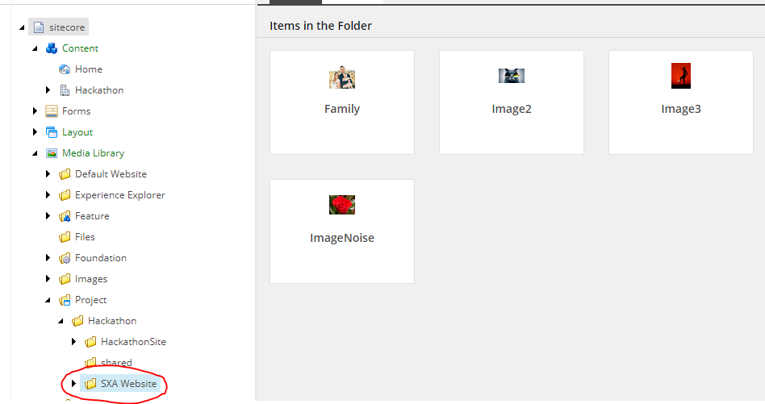

* Template instances are on **/sitecore/content/Hackathon/SXA Website/Data/Media**

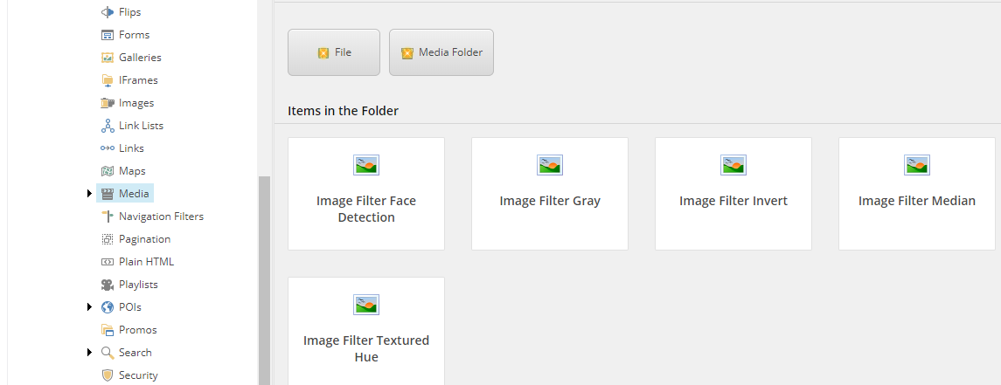

* Home page is located on **/sitecore/content/Hackathon/SXA Website/Home**

